MySQL server

1. Run the following script to install **MySQL community server** on EC2

#!/bin/bash

sudo yum -y update

sudo yum -y upgrade

sudo amazon-linux-extras install epel -y

sudo yum -y install https://dev.mysql.com/get/mysql80-community-release-el7-10.noarch.rpm

sudo yum -y install mysql-community-server

sudo systemctl start mysqld

sudo systemctl enable mysqld

2. check the status of mysqld service

Sudo systemctl status mysqld

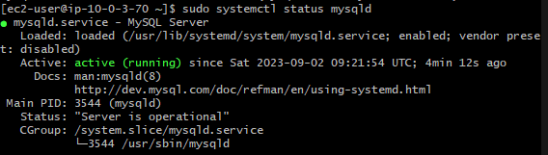

3. Find the Initial root Password

A password for the superuser is set and stored in the error log file. To reveal it, use the following command:

Sudo cat /var/log/mysqld.log | grep “temporary”



4. Execute the following command from the terminal:

sudo mysql_secure_installation

Enter the root password found in the above step, then set a new password for the MySQL root account. Next, follow the onscreen instructions and Press Y for all other operations to apply improved security.

* Enter password for user root: **[Enter current root password]**
* New password: **[Enter a new root password]**
* Re-enter new password: **[Re-Enter the new root password]**
* Estimated strength of the password: 100  
  Change the password for root ? ((Press y|Y for Yes, any other key for No) : **n**
* Remove anonymous users? (Press y|Y for Yes, any other key for No) : **y**
* Disallow root login remotely? (Press y|Y for Yes, any other key for No) : **y**
* Remove test database and access to it? (Press y|Y for Yes, any other key for No) : **y**
* Reload privilege tables now? (Press y|Y for Yes, any other key for No) : **y**

5. connect to MySQL server locally

Mysql -u root -p

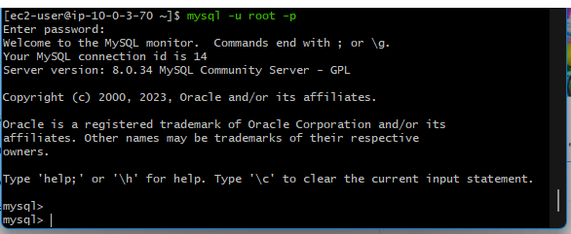

6. allow connect remotely to MySQL community server

SELECT host FROM mysql.user WHERE User = 'root';

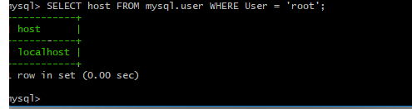

You will need to add the IP address of each host that you want to grant access to, and then grant privileges:

CREATE USER 'root'@'ip_address' IDENTIFIED BY 'some_pass';

GRANT ALL PRIVILEGES ON *.* TO 'root'@'ip_address';

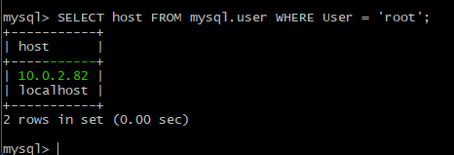

In case of the following error

altering the user

ALTER USER 'root'@'ip_address' IDENTIFIED WITH mysql_native_password BY 'some_pass';

or when creating the user:

CREATE USER 'username'@'localhost' IDENTIFIED WITH mysql_native_password BY 'password';

